**Designing a Dimensional Model for Sales Analysis and SQL Queries**

**Data Analysis of Car Repair Shop’s Operations**

**Part B - SQL Queries and Insights**

#### **Table of Contents**

* Introduction
* Data Ingestion and Preparation
* Customer Analysis
* Vehicle Analysis
* Job Performance Analysis
* Parts Usage Analysis
* Financial Analysis
* Optimization Recommendations
* Conclusion

**Introduction**

In this report, we present the data analysis of the car repair shop’s operations, focusing on insights derived from an extended set of sales receipts. The task involves importing CSV files into a relational database, cleaning and preparing the data, and performing detailed SQL queries to analyse various aspects of the shop's performance.

The purpose of this data analysis is to extract meaningful insights that can help the car repair shop optimise its operations, improve customer satisfaction, and increase profitability. By examining customer spending patterns, vehicle service trends, job performance, parts usage, and financial metrics, we aim to provide actionable recommendations for the business.

Deriving insights from the car repair shop’s data is crucial for making informed decisions. Understanding customer behaviour, identifying common vehicle issues, and evaluating the effectiveness of services and parts can lead to better inventory management, targeted marketing efforts, and enhanced operational efficiency. This analysis will enable the shop to make data-driven decisions that drive growth and profitability.

**Data Ingestion and Preparation**

In this section, we outline the process of cleaning, properly formatting, and indexing the provided CSV files for efficient querying, As Well as the importation/imputation of the cleaned files into our relational database.

The process began with cleaning and formatting the provided files. This included adding more tables, standardising data formats (e.g., Number formats and text casing), and handling missing data, also making sure foreign keys in the fact tables were properly linked to the dimension tables.

Nulls must be avoided in the fact table’s foreign keys because these nulls would automatically cause a referential integrity violation. Rather than a null foreign key, the associated dimension table must have a default row (and surrogate key) representing the unknown or not applicable condition. Our dimensional location table only has one entry and it is the location of the car repair shop provided from the sample invoice, as no location dimension was given the original CSV files and in order to maintain referential integrity, all sales entries were assumed to have happened at the same location. These steps ensured that the data was accurate and ready for importation/ imputation.

Once the data was cleaned we attempted to import our data into our database but ran into `--secure-file-priv` issues and after much trouble shooting none of the solutions were feasible. Hence we populated our relational database with data from the CSV files using simple insert queries as our data was not large. This was achieved using SQL scripts to create the necessary tables and populate them with data from the CSV files.

To optimise the database for efficient querying, indexing strategies were implemented. Indexes were auto incremented on key columns such as CustomerID, Vehicle ID, ServiceID, ParTID, DateID etc.. These indexes improved the speed of data retrieval, allowing for faster and more efficient execution of SQL queries during the analysis phase.

**Customer Analysis**

**SQL QUERY:**

-- Top 5 customers who have spent the most on vehicle repairs and parts

SELECT c.Name, SUM(s.TotalAmount) as TotalSpent

FROM Sales s

JOIN DimCustomer c ON s.CustomerID = c.CustomerID

GROUP BY c.CustomerID, c.Name

ORDER BY TotalSpent DESC

LIMIT 5;

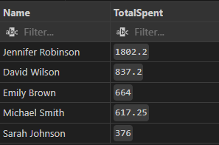

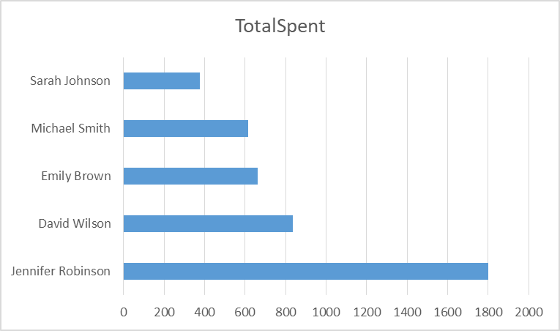

This bar chart shows the total amount spent by each customer on vehicle repairs and parts. Jennifer Robinson stands out as the highest spender, with a total expenditure significantly higher than the other customers, followed by David Wilson. Sarah Johnson, Emily Brown, and Michael Smith have comparatively lower total spending.

**SQL QUERY:**

-- Average spending of customers on repairs and parts

SELECT AVG(TotalSpent) as AverageSpending

FROM (

SELECT c.CustomerID, SUM(s.TotalAmount) as TotalSpent

FROM Sales s

JOIN DimCustomer c ON s.CustomerID = c.CustomerID

GROUP BY c.CustomerID

) as CustomerSpending;

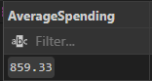

The average spending of customers on repairs and parts is calculated to be $859.33. This metric helps in understanding the general spending behavior of the shop's customers. It provides a benchmark to identify high and low spenders and evaluate overall customer spending trends.

**SQL QUERY:**

-- Frequency of customer visists

SELECT c.Name, COUNT(*) as VisitCount

FROM Sales s

JOIN DimCustomer c ON s.CustomerID = c.CustomerID

GROUP BY c.CustomerID, c.Name

ORDER BY VisitCount DESC;

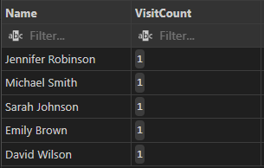

**SQL QUERY:**

--enhanced query using date table for context

SELECT c.Name, COUNT(*) as VisitCount, MIN(d.Date) as FirstVisit, MAX(d.Date) as LastVisit

FROM Sales s

JOIN DimCustomer c ON s.CustomerID = c.CustomerID

JOIN DimDate d ON s.DateID = d.DateID

GROUP BY c.CustomerID, c.Name

ORDER BY VisitCount DESC;

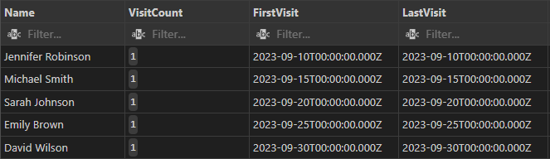

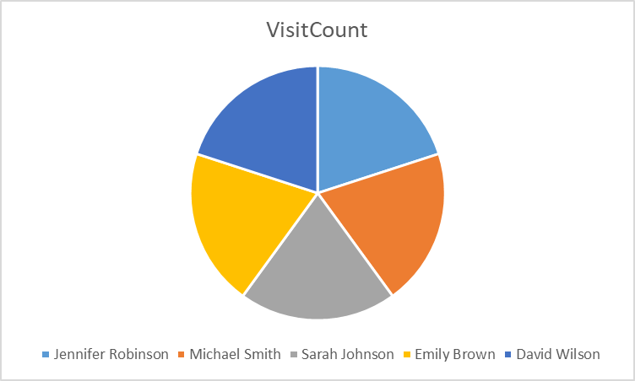

The pie chart illustrates the visit frequency of each customer. The distribution shows that all customers, including Jennifer Robinson, Michael Smith, Sarah Johnson, Emily Brown, and David Wilson, have an even distribution of visit counts. From the query results that includes the dates they came, we see they each came once to the repair shop.

**Vehicle Analysis:**

**SQL QUERY:**

-- Average mileage of vehicles serviced

SELECT AVG(Mileage) as AverageMileage

FROM DimVehicle;

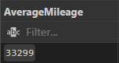

The average mileage of vehicles serviced at the car repair shop is calculated to be 33,299 miles. This metric helps in understanding the typical usage of vehicles that come in for repairs and can be useful in predicting the types of services required based on mileage.

**SQL QUERY:**

-- Most common vehicle makes and models brought in for service

SELECT Make, Model, COUNT(*) as ServiceCount

FROM DimVehicle

GROUP BY Make, Model

ORDER BY ServiceCount DESC

LIMIT 5;

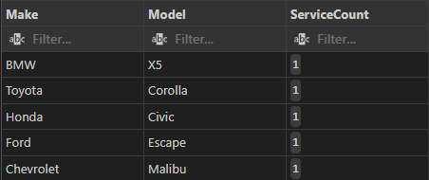

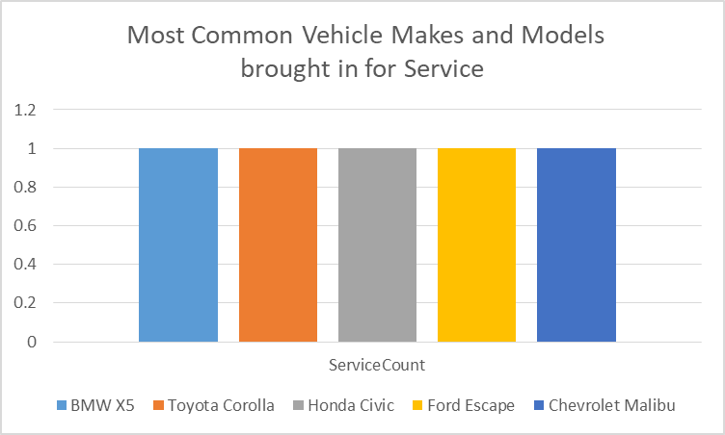

The service count for all vehicles is 1, indicating that each vehicle make and model in the dataset has been serviced once. This result suggests a diverse range of vehicle makes and models being brought in for service, without any particular make or model standing out as the most common.

**SQL QUERY:**

-- Distribution of vehicle ages

SELECT

v.Make,

YEAR(CURDATE()) - v.Year as VehicleAge,

COUNT(*) as VehicleCount,

AVG(s.TotalAmount) as AvgServiceCost

FROM DimVehicle v

JOIN Sales s ON v.VehicleID = s.VehicleID

GROUP BY v.Make, VehicleAge

ORDER BY VehicleAge;

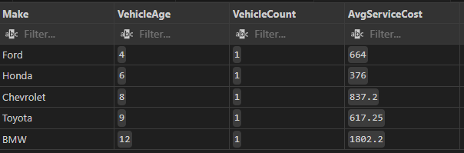

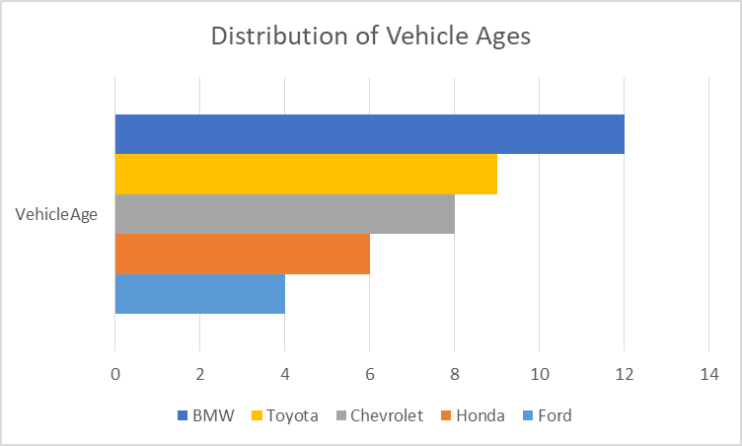

This bar chart shows the distribution of vehicle ages for different makes, including BMW, Toyota, Chevrolet, Honda, and Ford. BMW and Toyota vehicles have the highest representation in the older age brackets, indicating they are more likely to be serviced at the shop. Chevrolet and Honda have a moderate distribution across various ages, while Ford has a lower representation, particularly in older vehicle ages.

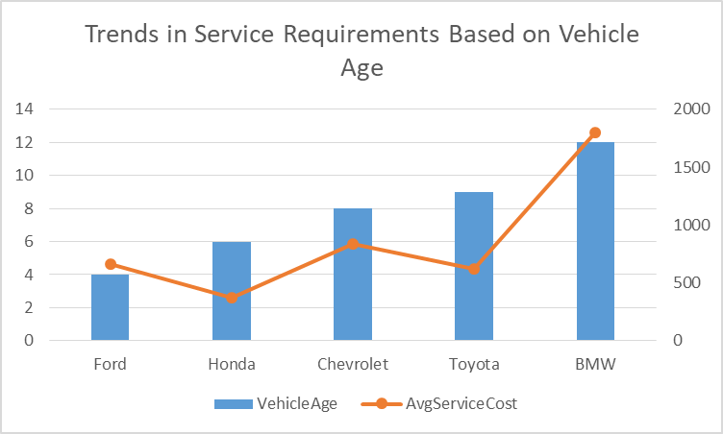

The combined line and bar chart illustrates the relationship between vehicle age and average service cost. The bar chart shows the ages for different vehicle makes, while the line chart represents the average service cost associated with these ages.

The analysis reveals that older BMW and Toyota vehicles tend to have higher service requirements and costs, indicating that these older models are likely to need more extensive repairs. Honda and Chevrolet show a steady service requirement trend, but their average service costs do not fluctuate as significantly as BMW and Toyota. Ford has fewer service requirements, which may suggest either lower maintenance needs or fewer older models being serviced.

**Job Performance Analysis:**

**SQL QUERY:**

-- Most common types of jobs and their frequency

SELECT Description, COUNT(*) as JobFrequency

FROM FactServiceDetail fsd

JOIN DimService ds ON fsd.ServiceID = ds.ServiceID

GROUP BY Description

ORDER BY JobFrequency DESC;

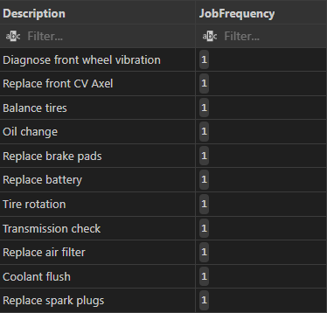

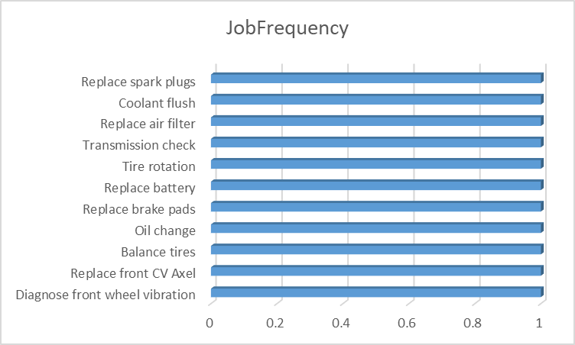

The job frequency chart shows that all listed jobs have the same frequency of 1. This suggests that in the given dataset:

* Each job type has been performed exactly once.
* There is no clear "most common" job type, as all are equally frequent.
* This could indicate a limited dataset, perhaps covering a short time period or a sample where each job happened to occur once.

While this doesn't provide insight into which jobs are typically more common, it does show the range of services offered by the shop.

**SQL QUERY:**

-- Total revenue from each type of job

SELECT Description, SUM(Amount) as TotalRevenue

FROM FactServiceDetail fsd

JOIN DimService ds ON fsd.ServiceID = ds.ServiceID

GROUP BY Description

ORDER BY TotalRevenue DESC;

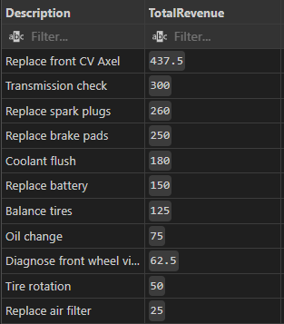

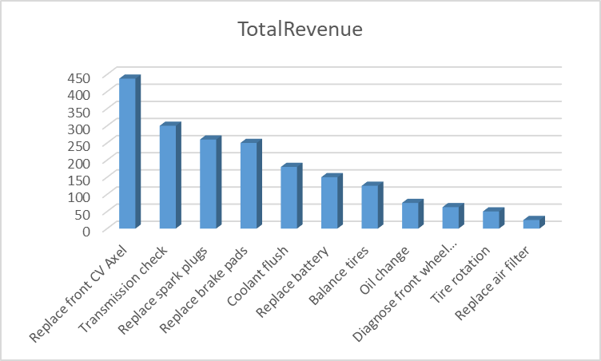

The total revenue chart and the corresponding table from the query results clearly show the revenue for each job type:

* Replace front CV Axel is the highest revenue generator at $437.5
* Followed by Transmission check at $300
* Replace spark plugs at $268
* Replace brake pads at $258
* The lowest revenue generators are Tire rotation at $50 and Replace air filter at $25

This data allows us to rank jobs by their contribution to overall revenue. It's clear that complex jobs like CV Axel replacement and transmission checks are significant revenue drivers for the shop.

**SQL QUERY:**

-- Jobs with highest and lowest average costs

-- Highest Average Cost

(SELECT Description, AVG(Amount) as AvgCost

FROM FactServiceDetail fsd

JOIN DimService ds ON fsd.ServiceID = ds.ServiceID

GROUP BY Description

ORDER BY AvgCost DESC

LIMIT 1)

UNION ALL

-- Lowest Average Cost

(SELECT Description, AVG(Amount) as AvgCost

FROM FactServiceDetail fsd

JOIN DimService ds ON fsd.ServiceID = ds.ServiceID

GROUP BY Description

ORDER BY AvgCost ASC

LIMIT 1);

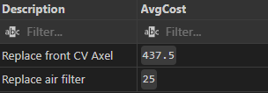

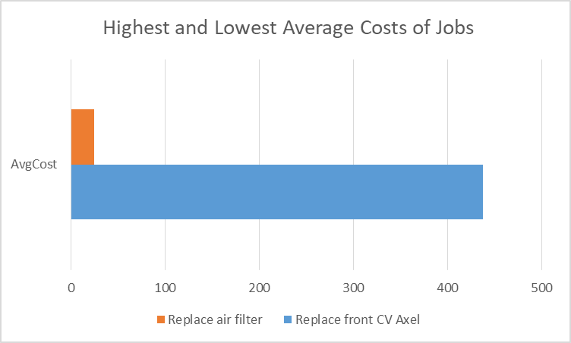

The "Highest and Lowest Average Costs of Jobs" chart (bottom of Image 1) and the AvgCost table (bottom right of Image 2) provide this information:

* Highest average cost: Replace front CV Axel at $437.5
* Lowest average cost: Replace air filter at $35

It's worth noting that in this dataset, the average cost seems to directly correlate with the total revenue for each job. This suggests that either: a) Each job was only performed once, so the average cost equals the total revenue, or b) The pricing is very consistent for each job type.

Overall insights:

* There's a wide range in job costs and revenues, from $35 to $437.5.
* More complex jobs (like CV Axel replacement) generate significantly more revenue than simpler tasks (like air filter replacement).
* The consistency in job frequency limits our ability to identify truly common jobs, but provides a clear picture of the revenue and cost structure for various services.
* The shop might want to focus on promoting higher-revenue services or find ways to increase the frequency of these more profitable jobs.
* For lower-revenue jobs, the shop could consider bundling them with other services to increase overall transaction value.

**Parts Usage Analysis:**

**SQL QUERY:**

-- Top 5 most frequently used parts

SELECT PartName, SUM(Quantity) as TotalUsage

FROM FactPartDetail fpd

JOIN DimPart dp ON fpd.PartID = dp.PartID

GROUP BY PartName

ORDER BY TotalUsage DESC

LIMIT 5;

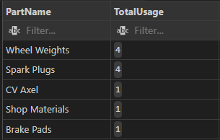

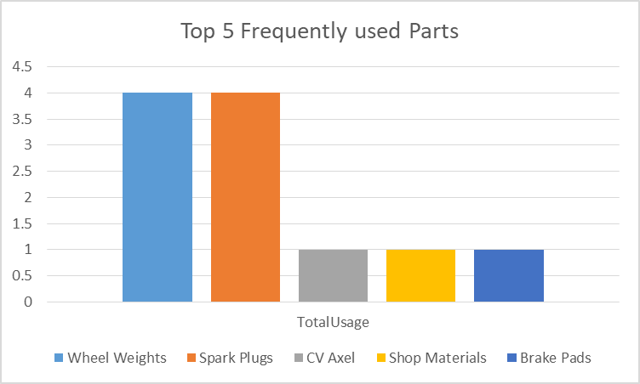

Top 5 most frequently used parts:

* Wheel Weights and Spark Plugs are tied for most frequent use (4 each)
* CV Axel, Shop Materials, and Brake Pads are next (1 each)

**SQL QUERY:**

-- Average cost of parts used in repairs

SELECT AVG(UnitPrice) as AvgPartCost

FROM DimPart;

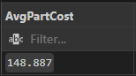

The average part cost is $148.887

**SQL QUERY:**

-- Total revenue from parts sales

SELECT SUM(Amount) as TotalPartsRevenue

FROM FactPartDetail;

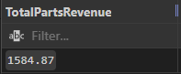

Total parts revenue is $1584.87

This analysis shows a mix of frequently used low-cost items (like wheel weights) and less frequent but likely more expensive parts (like CV Axel). The parts sales contribute significantly to the overall revenue.

**Financial Analysis:**

**SQL QUERY:**

-- Monthly revenue from labor and parts

SELECT

CONCAT(dd.Year, '-', dd.Month) as YearMonth,

SUM(s.TotalLabor) as LaborRevenue,

SUM(s.TotalParts) as PartsRevenue

FROM Sales s

JOIN DimDate dd ON s.DateID = dd.DateID

GROUP BY dd.Year, dd.Month

ORDER BY dd.Year, dd.Month;



For September 2023: Labor Revenue is $1598, Parts Revenue is $2035

**SQL QUERY:**

-- Overall profitability (Assuming some costs (e.g., 20% of labor costs and 30% of parts costs))

SELECT

SUM(s.TotalAmount) as TotalRevenue,

SUM(s.TotalAmount- (s.TotalLabor * 0.2) - (s.TotalParts * 0.3)) as TotalCost,

SUM(s.TotalAmount) - SUM(s.TotalAmount - (s.TotalLabor * 0.2) - (s.TotalParts * 0.3)) as Profitability

FROM Sales s;

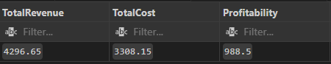

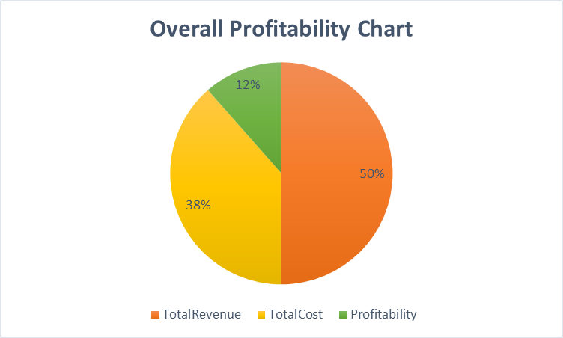

Overall profitability:

* Total Revenue: 50% of the pie chart
* Total Cost: 38% of the pie chart
* Profitability: 12% of the pie chart This indicates a healthy profit margin of 12%

**SQL QUERY:**

-- Impact of sales tax on total revenue

SELECT

SUM(TotalAmount) as TotalRevenue,

SUM(SalesTax) as TotalSalesTax,

(SUM(SalesTax) / SUM(TotalAmount)) * 100 as SalesTaxPercentage

FROM Sales;

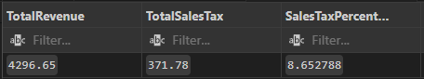

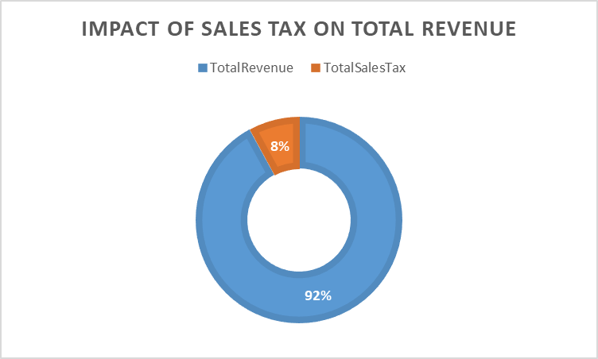

Impact of sales tax:

* + Total Revenue: 92% of the circle
  + Total Sales Tax: 8% of the circle Sales tax accounts for 8% of the total revenue, which is a significant portion that needs to be accounted for in pricing and financial planning.

These analyses provide insights into inventory management, pricing strategies, and overall financial health of the repair shop.

**Optimization Recommendations**

Based on the analysis of the car repair shop’s data, here are comprehensive recommendations to optimize operations, enhance overall business performance, and improve profitability:

1. **Identifying Underperforming Services:**

* **Focus on Improving or Marketing Lower-Revenue Services**: Services like tire rotation and air filter replacement are identified as underperforming. Enhance their profitability by bundling them with higher-value services. Investigate the reasons behind their low frequency or revenue, which could be due to pricing, demand, or efficiency issues.
* **Marketing Efforts**: Increase marketing efforts for these services through promotions or package deals, emphasising their importance in vehicle maintenance.

2. **Parts Inventory Management:**

* **Higher Stock of Frequently Used Parts**: Ensure a higher inventory of frequently used parts like wheel weights and spark plugs. This strategy will reduce downtime and improve service efficiency.
* **Balanced Inventory of Expensive Part**s: Maintain a balanced stock of more expensive, less frequently used parts like CV axles to ensure availability without overinvesting.
* **Just-in-Time Inventory System**: Implement a just-in-time inventory system for less frequently used parts to reduce carrying costs and improve inventory turnover.

3. **Customer Loyalty Program:**

* **Tiered Loyalty Program**: Implement a tiered loyalty program based on total spending or visit frequency. Offer discounts on high-margin services or parts, priority scheduling, and extended warranties for top-tier customers to encourage repeat business.

4. **Scheduling Adjustments:**

* **Prioritise High-Revenue Services**: While the current data shows equal frequency for all jobs, prioritise scheduling for high-revenue services like CV axle replacement and transmission checks. Allocate more time slots for these complex jobs.
* **Efficient Workflow for Quick Jobs**: Develop efficient workflow processes for quicker jobs like tire rotations and air filter replacements to fit them between longer services, maximising the use of available time slots.

5. **Profitability Improvements:**

* Increase Operational Efficiency: With a current profit margin of 12%, look for ways to increase efficiency in operations to boost this margin. Analyse the cost structure (38% of revenue) to identify areas for potential cost reduction without compromising quality.

6. **Pricing Strategy:**

* **Adjust Prices for Sales Tax Impact**: Consider adjusting prices to account for the 8% sales tax impact, ensuring it doesn't reduce profits. Implement dynamic pricing for high-demand services or during peak times to maximise revenue.

7. **Service Mix Optimization:**

* **Promote High-Revenue Services**: Actively promote high-revenue services like CV axle replacement and transmission checks through targeted marketing campaigns. Train staff to upsell these services during routine maintenance visits.

8. **Customer Education:**

* **Develop an Education Program**: Educate customers on the importance of regular maintenance, focusing on high-revenue services. This can drive more frequent visits and increase the uptake of preventive services, contributing to overall revenue growth.

9. **Technician Training:**

* **Invest in Training Programs**: Invest in training programs to improve technician efficiency, particularly in performing high-value services. This can potentially increase the number of these jobs completed daily, enhancing overall service capacity.

10. **Data Collection and Analysis:**

* **Implement Robust Data Collection Systems**: Develop systems to collect detailed data on customer behaviour, job frequencies, and parts usage. This will enable more nuanced analysis and data-driven decision-making in the future.

By implementing these recommendations, the car repair shop can optimise its operations, improve inventory management, enhance customer loyalty, and ensure better resource allocation. These changes, driven by data analysis, will contribute to increased profitability and a more efficient service delivery model.

### **Conclusion**

### In conclusion, the analysis of the car repair shop's data has yielded valuable insights that can significantly benefit the business. Key findings include:

* **Customer Analysis**: Identifying top-spending customers and average spending patterns can help tailor marketing strategies and loyalty programs to enhance customer retention.
* **Vehicle Analysis**: Understanding the distribution of vehicle ages and average mileage serviced allows for better inventory and service planning, ensuring the shop can meet customer needs efficiently.
* **Job Performance and Parts Usage Analysis**: Highlighting the most common jobs performed and frequently used parts helps optimise inventory management and prioritise high-revenue services.
* **Financial Analysis**: Evaluating total revenue and profitability metrics provides a clear picture of the shop's financial health, guiding strategic decisions to improve margins and operational efficiency.

These insights can help the car repair shop optimise its operations, improve customer satisfaction, and increase profitability. Implementing the recommendations, such as focusing on underperforming services, enhancing parts inventory management, and developing customer loyalty programs, will drive business growth and efficiency.

### **Future Steps**

To further leverage the data analysis:

* **Continuous Data Collection and Analysis**: Implement robust systems for ongoing data collection to enable continuous improvement and more nuanced future analysis.
* **Refinement of Inventory Management**: Develop and refine inventory management strategies based on usage patterns and demand forecasts.
* **Advanced Customer Analytics**: Utilise advanced analytics to gain deeper insights into customer behaviour and preferences, enabling more targeted marketing efforts.
* **Operational Efficiency Improvements**: Invest in training and process optimization to improve the efficiency and quality of service delivery.

By taking these future steps, the car repair shop can maintain a competitive edge and continue to enhance its service offerings, ultimately leading to sustained business success.

**Data**

Cleaned CSV files**:** [DB CSV Files](https://drive.google.com/drive/folders/1wPwQ6Wy5CZfarcHxnNPkCXTFhHI0OeB-?usp=sharing)

SQL Queries:  [Dimensional Model for Sales Analysis and SQL Queries](https://drive.google.com/file/d/1hbWdRWSyCu8KWNtAxv8X_1GQ8cRN93yx/view?usp=sharing)